

NATIONAL UNIVERSITY OF MODERN LANGUAGES AND SCIENCES
Software Construction and Development Lab
Semester BSSE 5
Lab no. 11
Department: Software Engineering
Course: Software Construction And Development Lab
Roll No. RCS-30243
Submitted to: Maam Saiqa Anjum
Submitted By: Ilsa Zahid
Dated: 29th April, 2026

LAB 11: Refactoring
Objective
Objective In this lab, students will improve code quality and maintainability by applying refactoring.
Given code:
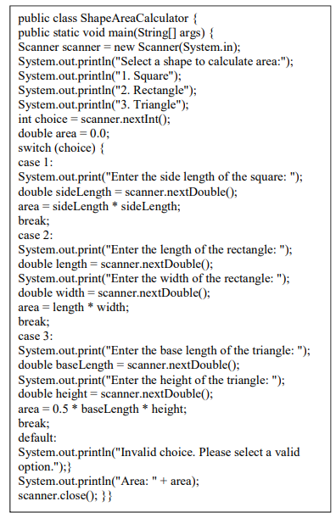

Identified Code Smells
The given code contains the following issues:
1. Long Method
- The main() method is doing everything:
  - Taking input
  - Handling logic
  - Calculating area
  - Printing output
- This makes it hard to understand and maintain.
2. Code Duplication
- Input handling and calculation logic are repeated for each shape.

3. Lack of Abstraction
- All logic is written in one place instead of separating responsibilities.

4. Poor Extensibility (Violates Open/Closed Principle)
- Adding a new shape requires modifying the switch statement.

5. Magic Numbers
- The value 0.5 is directly used in triangle calculation.

6. Dispensable Code Structure
- Everything is tightly coupled inside main() instead of reusable components.

Refactoring Techniques Applied
Problem | Refactoring Technique
Long Method | Extract Method
Code Duplication | Create separate classes
Lack of Abstraction | Use Abstraction (Interface)
Poor Extensibility | Polymorphism
Magic Numbers | Use Constants

Refactored Code
Step 1: Create Shape Interface
interface Shape {
double calculateArea();
}

Step 2: Implement Shape Classes
class Square implements Shape {
private double side;
public Square(double side) {
this.side = side;
}
public double calculateArea() {
return side * side;
}
}
class Rectangle implements Shape {
private double length;
private double width;
public Rectangle(double length, double width) {
this.length = length;
this.width = width;
}
public double calculateArea() {
return length * width;
}
}
class Triangle implements Shape {
private double base;
private double height;
private static final double HALF = 0.5;
public Triangle(double base, double height) {
this.base = base;
this.height = height;
}
public double calculateArea() {
return HALF * base * height;
}
}

Step 3: Refactored Main Class
import java.util.Scanner;
public class ShapeAreaCalculator {
public static void main(String[] args) {
Scanner scanner = new Scanner(System.in);
Shape shape = null;
System.out.println("Select a shape to calculate area:");
System.out.println("1. Square");
System.out.println("2. Rectangle");
System.out.println("3. Triangle");
int choice = scanner.nextInt();
switch (choice) {
case 1:
System.out.print("Enter side length: ");
double side = scanner.nextDouble();
shape = new Square(side);
break;
case 2:
System.out.print("Enter length: ");
double length = scanner.nextDouble();
System.out.print("Enter width: ");
double width = scanner.nextDouble();
shape = new Rectangle(length, width);
break;
case 3:
System.out.print("Enter base: ");
double base = scanner.nextDouble();
System.out.print("Enter height: ");
double height = scanner.nextDouble();
shape = new Triangle(base, height);
break;
default:
System.out.println("Invalid choice.");
scanner.close();
return;
}
System.out.println("Area: " + shape.calculateArea());
scanner.close();
}
}
Before vs After Comparison
Before | After
Long main() method | Small, focused classes
Switch-based logic | Polymorphism
Duplicate code | Reusable classes
No abstraction | Interface used
Hard to extend | Easy to add new shapes

Benefits After Refactoring
1. Improved Readability
- Code is divided into small, meaningful classes.
2. Improved Maintainability
- Changes can be made in one class without affecting others.
3. Reusability
- Shape classes can be reused in other programs.
4. Extensibility
- New shapes can be added without modifying existing code.
5. Follows OOP Principles
- Encapsulation
- Abstraction
- Polymorphism
Conclusion
Refactoring transformed the original monolithic code into a clean and modular design. By applying abstraction and polymorphism, the system became easier to maintain, extend, and understand. The final solution removes code duplication and follows good software engineering practices

